
Draw Guide
Chapter 2
Drawing Basic Shapes

Copyright
This document is Copyright © 2011–2014 by the LibreOffice Documentation Team. Contributors are listed below. You may distribute or modify it under the terms of either the GNU General Public License (http://www.gnu.org/licenses/gpl.html), version 3 or later, or the Creative Commons Attribution License (http://creativecommons.org/licenses/by/4.0/), version 4.0 or later.
All trademarks within this guide belong to their legitimate owners.

Contributors
John Cleland Martin Fox Jean Hollis Weber
John A Smith Peter Schofield

Feedback
Please direct any comments or suggestions about this document to the Documentation Team’s mailing list: documentation@global.libreoffice.org
Note: Everything you send to a mailing list, including your email address and any other personal information that is written in the message, is publicly archived and cannot be deleted.

Acknowledgments
This chapter is based on an original French document written for OpenOffice.org 1.x by Michel Pinquier (translated into English by Alex Thurgood) and previous content revised by Jim Taylor. The chapter was revised for OpenOffice.org 2.0 by Linda Worthington, Daniel Carrera, Jean Hollis Weber, and Agnes Belzunce, and later translated into German by Wolfgang Uhlig. The German revisions were then translated into English and updated for OpenOffice.org 3.3 by Martin Fox. Other contributors included Hazel Russman, Gary Schnabl, and Claire Wood.

Publication date and software version
Published 25 September 2014. Based on LibreOffice 4.3.

Note for Mac users
Some keystrokes and menu items are different on a Mac from those used in Windows and Linux. The table below gives some common substitutions for the instructions in this chapter. For a more detailed list, see the application Help.
Windows or Linux | Mac equivalent | Effect
Tools > Options menu selection | LibreOffice > Preferences | Access setup options
Right-click | Control+click and/or right-click depending on computer setup | Opens a context menu
Ctrl (Control) | ⌘ (Command) | Used with other keys
F5 | Shift+⌘+F5 | Opens the Navigator
F11 | ⌘+T | Opens the Styles and Formatting window

Contents
Copyright 2
Contributors 2
Feedback 2
Acknowledgments 2
Publication date and software version 2
Note for Mac users 2
Introduction 4
Custom shapes 4
Drawing basic shapes 4
Straight lines 5
Arrows 8
Different types of lines and arrows 8
Rectangles or squares 9
Ellipses and circles 9
Adding arc and segment tools to the Drawing toolbar 9
Arcs or segments 11
Curves or polygons 12
Curves 12
Polygons 12
Polygons 45° 13
Freeform lines 13
Glue points and connectors 13
Glue points 13
Connectors 14
Drawing geometric shapes 15
Basic shapes 15
Symbol shapes 15
Block arrows 15
Flowcharts 16
Callouts 16
Stars and banners 16
Adding text to drawings and objects 16

Introduction
You can create 2D and 3D objects in Draw. This chapter shows how to draw simple 2D objects. The following chapters describe how to work with and edit such objects. For more information on 3D objects, see Chapter 7 Working with 3D Objects.
All shapes, whether they are lines, rectangles, or more complicated shapes, are called objects. This is common notation in vector drawing software.
The drawing tools are found on the Drawing toolbar (Figure 1). This toolbar is normally located at the bottom of the workspace. If you do not see it, you can activate it by going toView > Toolbars on the main menu bar.
Figure 1: Drawing toolbar
As with all the components of LibreOffice, you can undock the Drawing toolbar and place it wherever you want to on the Draw workspace as a floating toolbar. You can also configure toolbars by adding, moving, hiding, or deleting toolbar icons. See Chapter 1 Introducing Draw for more information.
When you draw a shape, select one for editing or add text, the information field in the status bar (Figure 2) changes to reflect the action taken or in progress. See Chapter 1 Introducing Draw for more information on the status bar.
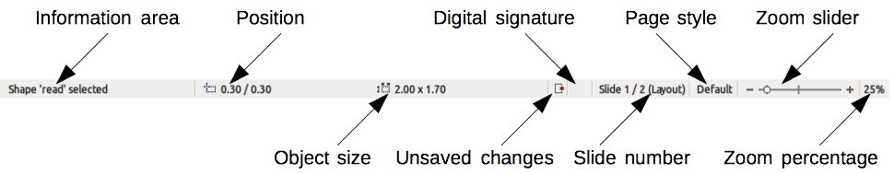
Figure 2: Draw status bar

Custom shapes
Draw also offers the ability to create custom shapes, which are the equivalent of AutoShapes in Microsoft Office. Custom shapes differ in their properties and are dealt with separately in the relevant chapters of this guide. The main differences relate to the behavior of 3D objects and text handling. Text frames in Draw have their own geometric format.

Drawing basic shapes
Basic shapes, including text, are treated as objects in Draw. The standard set of tools available for drawing basic shapes, from left to right on the Drawing toolbar, are shown in Figure 3.
The tools that are already placed on the Drawing toolbar are indicated by a darkened area around the icon, for example Select, Line and so on. The tools not on the Drawing toolbar do not have this darkened area around the icon, for example To Curve, To Polygon, and so on.
Please note that some of the icons on the Drawing toolbar will change shape according to the last tool used from the selection of available tools. The icons that have a small triangle to the right of the icon indicates that more tools are available. See “Drawing geometric shapes” on page 15 for information on the available shapes.
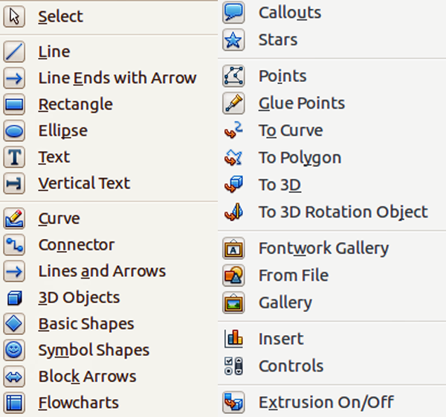
Figure 3: Tools available for Drawing toolbar
Note | When you draw a basic shape or select one for editing, the information area at the left side in the status bar changes to reflect the present action: for example Line created, Text frame xxyy selected, and so on.

Straight lines
A straight line is the simplest element or object in Draw to create.
- Click on the Line icon on the Drawing toolbar and place the cursor at the point where you want to start the line (Figure 4).
- Click and drag the cursor while keeping the mouse button pressed.
- Release the mouse button at the point where you want to end the line. When a line is selected, a large selection handle appears at the start of the line and a smaller selection handle appears at the end of the line.
- Keep the Shift key pressed while you draw a line to restrict the drawing angle of the line to a multiple of 45 degrees (0, 45, 90, 135, and so on).
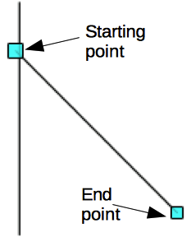
Figure 4: A straight line
Note | This is the default behavior of the Shift key. However, if the option When creating or moving objects in the Snap position section of Tools > Options > LibreOffice Draw > Grid has been selected, the action of the Shift key is the opposite. Lines will automatically be drawn at a multiple of 45 degrees unless the Shift key is pressed.
- Keep the Ctrl key pressed while drawing a line to enable the end of the line to snap to the nearest grid point.
Note | This is the default behavior of the Ctrl key. However, if the Snap to Grid option on the View->Grid menu has been selected, the Ctrl deactivates the snap to grid activity.
- Keep the Alt key pressed while drawing a line and the line extends outwards symmetrically in both directions from the start point. This lets you draw lines starting from the middle of the line.
- When a line is drawn, it uses default attributes. To change any of these attributes, select the line by clicking on it, then use one of the following methods:
- Use the tools on the Line and Filling toolbar to change line style, line width or line color.
- Go to Format > Line on the main menu bar, or right-click and select Line from the context menu to open the Line dialog (Figure 5) to change line attributes.
- Click on the Properties icon in the Sidebar to open the Properties section, then use the Line subsection (Figure 6) to change the line attributes.
- If necessary, go to Tools > Options > LibreOffice Draw > Grid on the main menu bar to adjust the spacing (resolution) of the grid points. See Chapter 3 Working with Objects and Object Points for more information.
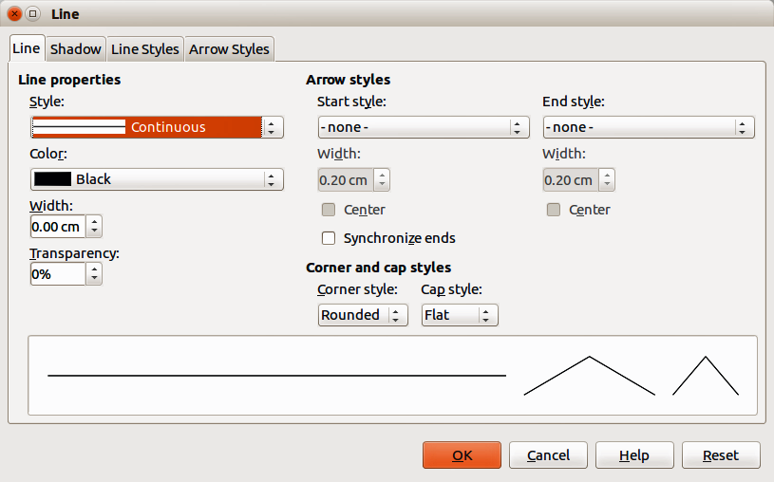
Figure 5: Line dialog – Line page
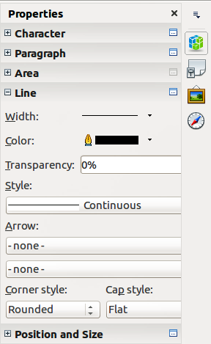
Figure 6: Sidebar Line subsection
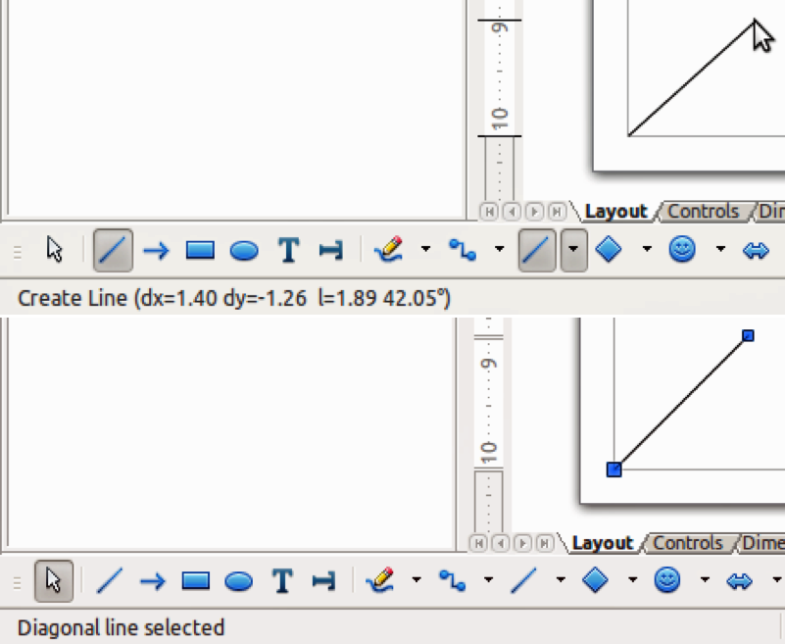
Figure 7: Information area in the Status bar
- While you are working with a line (or any other element), use the information field on the Status bar to monitor your activity. A description of the current activity or selection is shown when you are working with elements and Figure 7 shows two examples.

Arrows
Arrows are drawn like lines because Draw classifies arrows as a subgroup of lines, that is lines with arrowheads. The information field on the status bar shows them only as lines. Click on the Line Ends with Arrow icon to draw an arrow. The arrow head is drawn at the end point of the arrow when you release the mouse button.

Different types of lines and arrows
Click on the small triangle to the right of the Lines and Arrows icon on the Drawing toolbar to open a pop-up toolbar with tools for drawing lines and arrows. Alternatively, go to View > Toolbars > Arrows on the main menu bar to open the Arrows toolbar as a floating toolbar. The Lines and Arrows icon on the Drawing toolbar always indicates the last tool used and may not be the same as the Lines and Arrows icon shown above. Figure 8 shows the tools that are available on the Arrows toolbar.
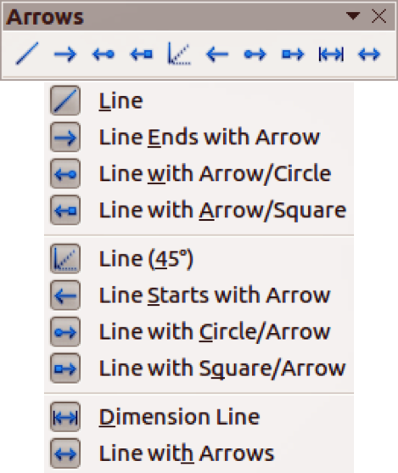
Figure 8: Arrows toolbar and available tools
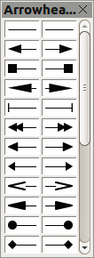
Figure 9: Available arrowheads
After drawing the line, you can change the arrow style by clicking on the Arrowheads icon in the Line and Filling toolbar and select the arrow start and end options. Start options are on the left and end options are on the right in Figure 9.

Rectangles or squares
Drawing a rectangle is similar to drawing a straight line. Click on the Rectangle icon in the Drawing toolbar. As you draw the rectangle with the mouse cursor, the rectangle appears with the bottom right corner of the rectangle attached to the cursor.
Squares are rectangles with all sides of equal length. To draw a square, click on the Rectangle icon and hold down the Shift key while you draw a square.
Note | If the option When creating or moving objects has been selected in Tools > Options > LibreOffice Draw > General, the action of the Shift key is reversed. When the Rectangle tool is selected, a square is drawn. To draw a rectangle you have to press the Shift key when drawing. This Shift key reversal also applies when drawing ellipses and circles in “Ellipses and circles” on page 9.
To draw a rectangle or square from its center rather than the bottom right corner, position your cursor on the drawing, press the mouse button and then hold down the Alt key while dragging with the cursor. The rectangle or square uses the start point where you first clicked the mouse button as the center.
With the rectangle or square selected, you can quickly change border style, line width, or color, and the type of fill color or fill pattern using the tools on the Line and Filling toolbar. For more information on changing the attributes of a rectangle or square, see Chapter 4 Changing Object Attributes.

Ellipses and circles
To draw an ellipse (also called an oval), click on the Ellipse icon on the Drawing toolbar. A circle is an ellipse with both axes the same length. To draw a circle, click on the Ellipse icon and hold down the Shift key while you draw a circle.
To draw an ellipse or circle from its center, position your cursor on the drawing, press the mouse button and then hold down the Alt key while dragging with the cursor. The ellipse or circle uses the start point (where you first clicked the mouse button) as the center.
With the ellipse or circle selected, you can quickly change border style, line width, or color, and the type of fill color or fill pattern using the tools on the Line and Filling toolbar. For more information on changing the attributes of an ellipse or circle, see Chapter 4 Changing Object Attributes.
Tip | To quickly insert a line, rectangle, ellipse, or text, press and hold the Ctrl key down and then click on one of the icons for line, rectangle, ellipse, or text. An object is drawn automatically in the center of the workspace area using default values. The object attributes can then be changed using the Line Fill toolbar or the information in Chapter 4 Changing Object Attributes. This works only if the icon has no associated toolbar; that is, no triangle or arrow on the right side of the icon.

Adding arc and segment tools to the Drawing toolbar
If you regularly draw arcs or segments (partial circles or ellipses), then you can add the Circles and Ovals toolbar (Figure 10) to the Drawing toolbar. The Circles and Ovals toolbar is an optional toolbar and you have to customize the Drawing toolbar to add this optional toolbar.
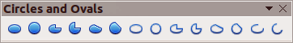
Figure 10: Circles and Ovals toolbar
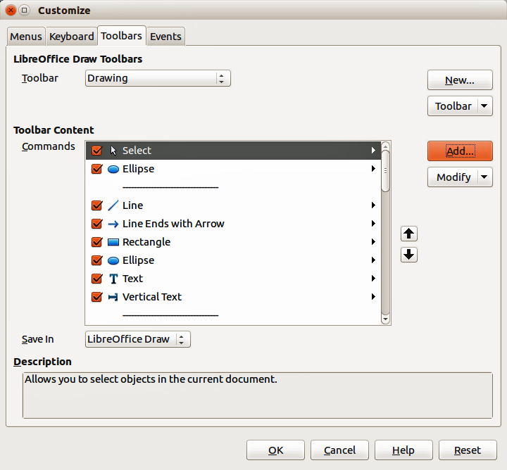
Figure 11: Customize dialog
- Go to View > Toolbars > Customize on the main menu bar, or right-click in a blank area in the Drawing toolbar and select Customize Toolbar from the context menu to open the Customize dialog (Figure 11).
- Select the Toolbars tab to open the Toolbars page of the Customize dialog.
- Select Drawing from the Toolbar drop down list and click Add to open the Add Commands dialog (Figure 12).
- Select Drawing in the Category list.
- Scroll down and select the second Ellipse command in the Commands list. Check the Description section at the bottom of the dialog as this will indicate that you have selected the command for the Circles and Ovals toolbar.
- Click Add and then click Close.
- In the Customize dialog, make sure the new Ellipse command is selected and checked.
- For clarity, click Modify > Rename and type in Circles and Ovals as the new name for this command, then click OK.
- Use the up and down arrow buttons to move the new Circles and Ovals command to the desired position on the Drawing toolbar.
- Click OK to save the customized Drawing toolbar and close the Customize dialog.
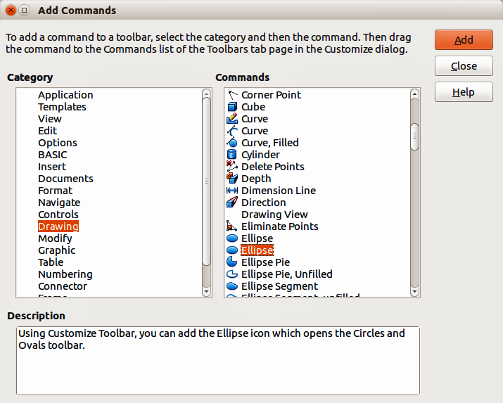
Figure 12: Add Commands dialog
Note | The icon used to open the Circles and Ovals toolbar is still called Ellipse and is not to be confused with the Ellipse icon that is one of the default tools placed on the left of the Drawing toolbar.
The new Circles and Ovals (Ellipse) icon appears on the Drawing toolbar with a small triangle to the right of it. Click on this triangle to open the Circles and Ovals toolbar (Figure 10). To make this toolbar into a floating toolbar, drag the toolbar onto the workspace area. The Circles and Ovals icon on the Drawing toolbar always indicates the last tool used and may not be the same as the Circles and Ovals icon shown above.
To help prevent any confusion, you can remove the standard Ellipse icon from the Drawing toolbar by opening the Customize dialog (Figure 11) and deselecting the first Ellipse command in the Commands list. Alternatively, select the first Ellipse command, click Modify > Delete to remove the Ellipse icon from the Drawing toolbar.
To return the Drawing toolbar to its default settings, open the Customize dialog, select the Circles and Ovals (Ellipse) icon, then click Modify > Delete to remove the icon from the Drawing toolbar.

Arcs or segments
- To draw an arc or segment, select the appropriate icon in the Circles and Ovals toolbar (Figure 10).
- Click and drag with the cursor to create a guide circle or ellipse.
- Move the cursor to the position where you want the arc or segment to start. The status bar indicates the angle in degrees.
- Click to start drawing the arc or segment, then move the cursor to create the arc or segment. The status bar shows the angle in degrees.
- When you have drawn the arc or segment you require, click again to complete the arc or segment.

Curves or polygons
To draw a curve or polygon, click the Curve icon on the Drawing toolbar. Click on the triangle to the right of the icon to open the toolbar (Figure 13). The Curve icon on the Drawing toolbar always indicates the last tool used and may not be the same as the Curve icon shown above. Hovering the cursor over this icon gives a tooltip of Curve. If you open the floating toolbar, the toolbar title is Lines.
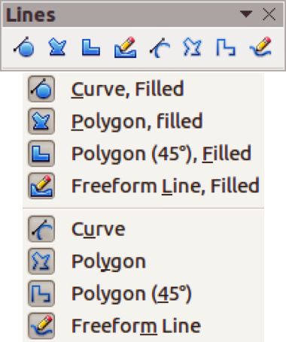
Figure 13: Curves (Lines) toolbar

Curves
- Click and hold the left mouse button to create the starting point of your curve, then drag from the starting point to draw a line.
- Release the left mouse button and continue to drag the cursor to bend the line into a curve.
- Click to set the end point of the curve and fix the curve on the page. Only the first section of your curve is drawn as a curve.
- To continue with your curve, click and drag the cursor to draw a straight line. Each mouse click sets a corner point and allows you to continue drawing another straight line from the last corner point.
- Double-click to end the drawing of your curve.
If you selected a filled curve, the last point is automatically joined to the first point to close off the curve and fills it with the current standard fill color. A curve without filling will not be closed when you end the drawing.

Polygons
- Click and draw the first line from the start point while holding the left mouse button held down.
- Release the mouse button when you have reached the second point of your polygon and a line between the first and second points is drawn.
- Move the cursor to where you want the next point point in your polygon and click the mouse button to draw the next line.
- Double-click to end the drawing of your polygon.
If you selected a filled polygon, the last point is automatically joined to the first point to close off the polygon and fills it with the current standard fill color. A polygon without filling will not be closed when you end the drawing.

Polygons 45°
These polygons are drawn the same way as ordinary polygons above, but the angles between lines are restricted to 45 or 90 degrees when you create another point in your polygon.
Note | Holding down the Shift key when drawing lines with the Curve or Polygon tools will also restrict the angles between the lines to 45 or 90 degrees.

Freeform lines
Using the Freeform Line tools is similar to drawing with a pencil on paper.
- Click and drag the cursor to the line shape you require.
- Release the mouse button when you are satisfied with your freeform line and the drawing is completed.
If you selected a filled freeform line, the last point is automatically joined to the first point to close off the freeform line and fills it with the current standard fill color. A freeform line without filling will not be closed when you end the drawing.

Glue points and connectors

Glue points
All Draw objects have glue points, which normally are not displayed. Glue points become visible when the Connectors icon on the Drawing toolbar is selected.
Most objects have four glue points (Figure 14). You can add more glue points and customize glue points using the Gluepoints toolbar (Figure 15). Go to View > Toolbars > Gluepoints on the main menu bar to open the toolbar.
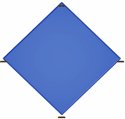
Figure 14: Gluepoints
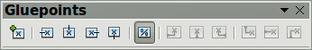
Figure 15: Gluepoints toolbar
Glue points are not the same as the selection handles of an object. The selection handles are for moving or changing the shape of an object, as described in Chapter 3 Working with Objects and Object Points.
Glue points are used to fix or glue a connector to an object so that when the object moves, the connector stays fixed to the object. For a more detailed description on the use of glue points, see Chapter 8 Connections, Flowcharts and Organization Charts.

Connectors
Connectors are lines or arrows whose ends automatically snap to a glue point of an object. Connectors are useful in drawing organization charts, flow diagrams, and mind-maps. When objects are moved or reordered, the connectors remain attached to a glue point. Figure 16 shows an example of two objects and a connector.
Draw offers a range of different connectors and connector functions. Click on the triangle to the right of the Connector icon to open the Connectors toolbar (Figure 17). The Connector icon on the Drawing toolbar always indicates the last tool used and may not be the same as the Connector icon shown above.
For a more detailed description of the use of connectors, see Chapter 8 Connections, Flowcharts and Organization Charts.
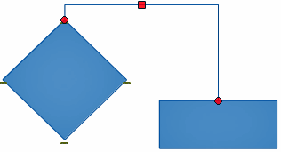
Figure 16: A connector between two objects
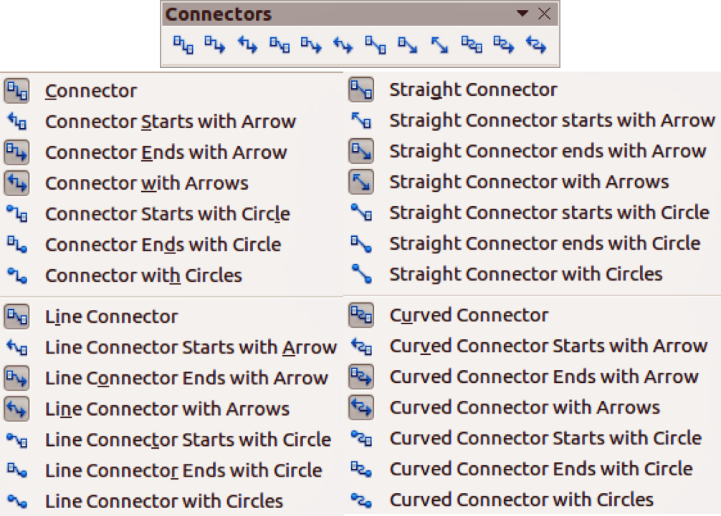
Figure 17: Connectors toolbar

Drawing geometric shapes
The icons for drawing geometric shapes are located on the Drawing toolbar and each geometric shape is explained in the following sections. Clicking on the triangle to the right of the icon opens a floating toolbar giving access to the tools for that geometric shape.
The use of these tools for geometric shapes is similar to the tool used for drawing rectangles and squares. For more information, see “Rectangles or squares” on page 9.
The icons used on the Drawing toolbar for drawing geometric shapes always indicates the last tool used and may not be the same as the icons shown in the following sections.

Basic shapes
Click on the triangle to the right of the Basic Shapes icon to open the Basic Shapes toolbar (Figure 18) for drawing basic shapes. This toolbar also includes a rectangle tool identical to the one already displayed on the Drawing toolbar.
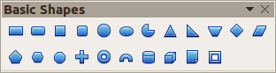
Figure 18: Basic Shapes toolbar

Symbol shapes
Click on the triangle to the right of the Symbol Shapes icon to open the Symbol Shapes toolbar for drawing symbols.
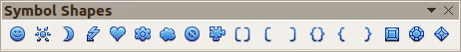
Figure 19: Symbol Shapes toolbar

Block arrows
Click on the triangle to the right of the Block Arrows icon to open the Block Arrows toolbar for drawing block arrows.
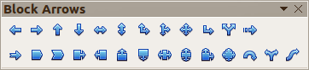
Figure 20: Block Arrows toolbar
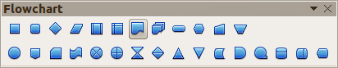
Figure 21: Flowcharts toolbar

Flowcharts
Click on the triangle to the right of the Flowcharts icon to open the Flowchart toolbar for symbols used in drawing flowcharts. The creation of flowcharts, organization charts, and similar planning tools are further described in Chapter 8 Connections, Flowcharts and Organization Charts.

Callouts
Click on the triangle to the right of the Callouts icon to open the Callouts toolbar for drawing callouts.
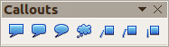
Figure 22: Callouts toolbar

Stars and banners
Click on the triangle to the right of the Stars icon to open the Stars and Banners toolbar for drawing stars and banners.
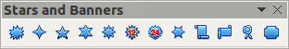
Figure 23: Stars and Banners toolbar

Adding text to drawings and objects
In Draw you can add, insert, and format text to a drawing, objects, and shapes as follows:
- As a dynamic text frame, which is an independent Draw object and expands as you add more text within the frame.
- Text within a previously drawn object. This integrates text within the object and is placed within the boundary rectangle that surrounds an object. This boundary rectangle is not dynamic and care must be taken so that your text does not go outside of the object boundaries.
For more information on how to add, insert, and format text in a drawing or drawing objects, see Chapter 9 Adding and Formatting Text.

